Lesson Plan
Review: Where Are We?
Lesson 1: Baby Moses
Lesson 2: Moses’ Life
Lesson 3: Moses – Deliverer of Israel
Lesson 4: God Sends Ten Plagues
Lesson 5: The Ten Plagues Continued
Lesson 6: The Passover
Lesson 7: The Exodus
Lesson 8: God Provided Food for Israel
Lesson 9: Israel versus the Amalekites
Lesson 10: Moses and Jethro
Lesson 11: The Ten Commandments
Lesson 12: Israel Creates a Golden Calf
Lesson 13: The Tabernacle
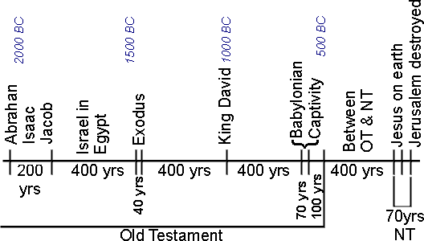

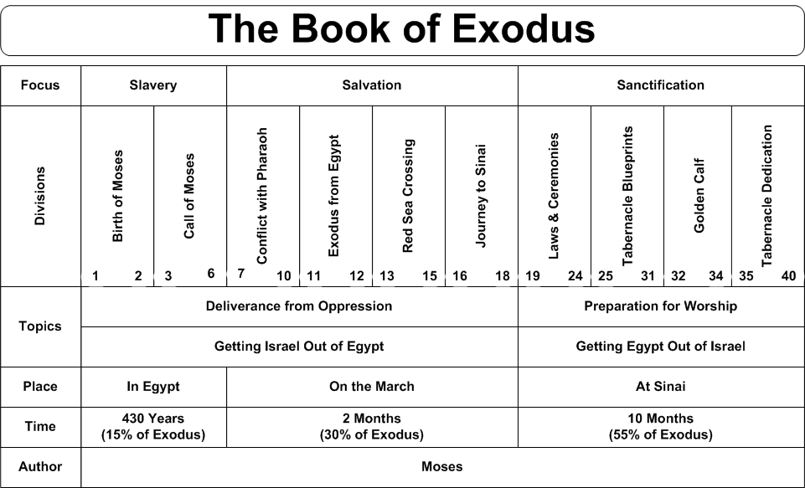

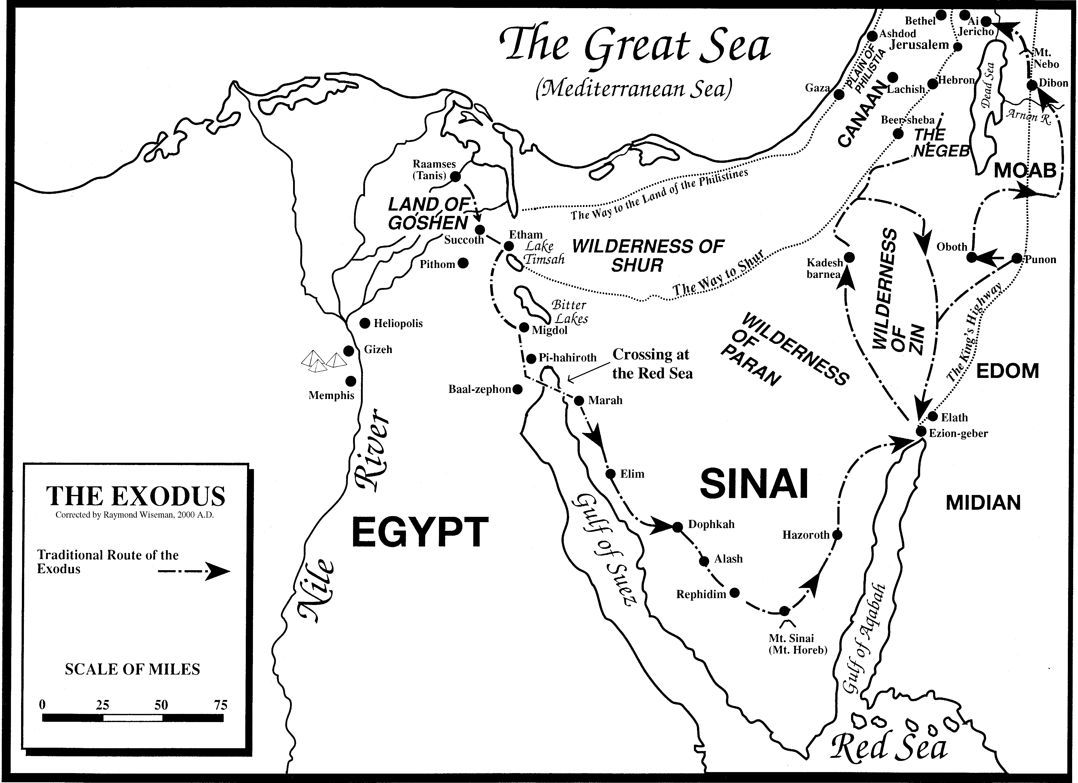

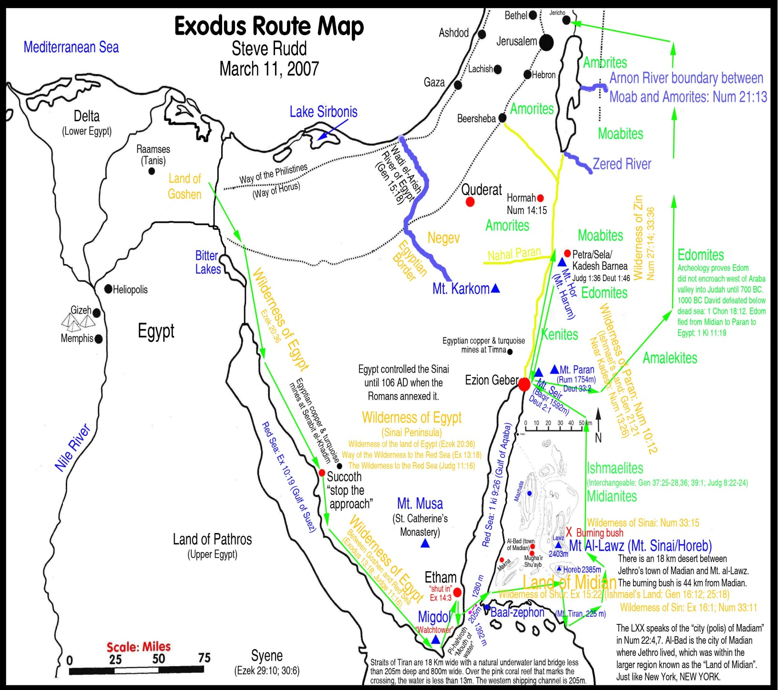

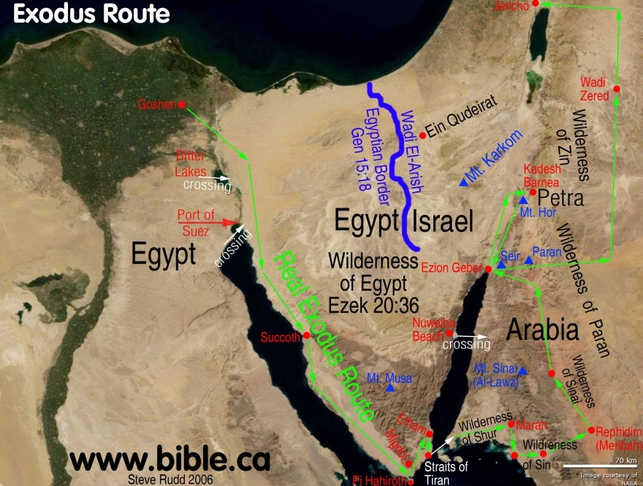

Lesson 1: Baby Moses
Lesson Text Exodus 1:1 – 2:10
More Readings - Hebrews 11:23-29, Acts 7:20-22

The Growth of the Children of Israel in Egypt (1:1-7)
- How did the children of Israel come to be in Egypt?

- What promise to Jacob was fulfilled in Egypt?
The Beginning of Oppression (1:8-22)
- What words to Abraham were fulfilled in Egypt?

- Why did the new king of Egypt begin to afflict the Israelites?

- Describe the measures taken against the Israelites.
The Birth of Moses (2:1-10)
- Name both the father and mother of Moses.

- How did the parents of Moses show their faith in God?

- Why was it necessary to hide Moses at birth?

- Did the mother of Moses, in a way, obey the king? Explain.

10. Why was Moses brought up as “the son of Pharaoh’s daughter?” What would be the effect of being brought up that way?
11. How did Moses learn who he was, who his people were, and about the true God?

Concept for this lesson is …

This text has meaning to me because…

Lesson 2: Moses’ Life
Lesson Text Exodus 2:11-25
More Readings – Exodus 3:1-6, Acts 7:23-29
His Flight to Midian (2:11-15)
1. According to Acts 27:23-25:
a. How old was Moses at this time?
b. What was Moses trying to do when he killed the Egyptian?
2. According to Hebrews 11:24-27:
a. What important decision did Moses have to make?
b. What were his choices?
c. What did he decide to do?
d. Are there parallel situations in our lives today in which we are called upon to make important decisions? Explain.
3. Were the Israelites ready to accept the leadership of Moses at this time? What was he forced to do?
4. How were the Midianites related to the Israelites?
His Marriage to Zipporah (2:16-22)
5. Who was Moses’ father-in-law? His wife? His first son?
6. How is Moses’ father-in-law identified in Exodus 3:1?
7. Why do you think Moses was called “an Egyptian” in vs. 19?
The Cry of the Israelites (2:23-25)
8. How is this passage an introduction to chapter 3?
9. What “covenant” is meant in vs 24?

Concept for this lesson is …

This text has meaning to me because …

Lesson Three: Moses – Deliverer of Israel
Lesson Text Exodus 3:1 – 7:13
More Readings – Exodus 5,6,7:1-13, Acts 7:30-34, James 1:13
The Manifestation of God in the Burning Bush (3:1-12)
1. How much time had passed since Moses left Egypt?
2. Who appeared to Moses? How? How else is this person described?
3. What made this place “holy ground”?
4. What was the reason or purpose for this revelation of God?
5. How does God respond to Moses’ excuses? What qualities does God show toward him?
6. What assurance of success is given to Moses? What lesson, if any, can be learned from this?
7. What would be the “token” given to Moses that God had indeed sent him? How would it serve as a token? What would it show?
The Name of God and the Mission of Moses (3:13-22)
8. What is the meaning of the question, “What is his name?” Is it a question about a proper name or something else? Explain.
9. What name did God use for Himself? What is it’s significance?
10. What is meant by calling Canaan “a land flowing with milk and honey”?
11. What advance warning did God give Moses?
12. What is meant by the phrase “you shall not go empty-handed? Was it right for the Israelites to ask these things of the Egyptians? Explain.
Three Signs (4:1-9)
13. What three signs did God give Moses?
14. In what kind of situation would one expect signs to be provided? (Mark 16:20; II Corinthians 12:12, Hebrews 2:1-4)
Aaron, Moses’ Spokesman (4:10-17)
15. What new difficulty is brought forward by Moses?
16. Even though God responded to the difficulties raised by Moses with patience, what finally aroused His anger against Moses?
17. What solution to the difficulty of verse ten is provided by God?
Moses’ Return to Egypt (4:18-31)
18. What forewarning did God give Moses as to what Pharaoh’s attitude would be?
19. In what way was Moses to communicate to Pharaoh the gravity of God’s demand?
20. What strange incident happened on the way to Egypt? Explain it in light of Genesis 17:9-14.
21. Who met Moses on the way? Where did he meet him?
22. What did Moses and Aaron do upon reaching Egypt? What was the reaction of the people to what they said?

The First Approach to Pharaoh and Its Consequences (5:1-21)
23. What was Pharaoh’s question when Moses and Aaron appeared before him?
24. Instead of letting the children of Israel go, what did Pharaoh do?
God’s Reassurance to Moses (5:22 – 6:9)
25. What reassurance was given to Moses by God?
26. List the things God promised to do for the children of Israel. What was their reaction when told of them?
The Charge to Moses (6:10-13, 28-30; 7:1-7)
27. What charge was given to Moses? Describe his feelings as he faced his task.
28. What was the evident purpose of God’s reply to Moses in 7:1-3? What is meant by “I have made you as God to Pharaoh”?
29. By what means would God bring Israel out of Egypt? What would be the effect of delivering them by such a means?
30. How old were Moses and Aaron when they stood before Pharaoh?
The Genealogy of Moses and Aaron (6:14-27)
31. Judging from its closing (vs 26-27), what is the purpose of this passage?
32. Comparing this list with the one given in Genesis 46:8-27, what is the primary difference?

The Second Appearance Before Pharaoh (7:8-13)
33. How did Moses and Aaron support their request the second time they appeared before Pharaoh?
34. In reaction to Moses and Aaron, what did Pharaoh’s magicians do?
35. How was the superiority of Moses and Aaron shown?

Concept for this lesson is …

This text has meaning to me because …

Lesson Four: God Sends Ten Plagues
Lesson Text Exodus 7:14 – 9:7

The First Plague: Water to Blood (7:14-25)
1. Describe the first plague God brought against Israel.
2. What seems to have hardened Pharaoh’s heart so that he did not listen to Moses and Aaron?
3. How do you think this miracle could be counterfeited?
The Second Plague: Frogs (8:1-15)
4. Describe the effect of this plague upon Egyptian life.
5. What additional wonder was worked through Moses and Aaron which the magicians of Egypt could not duplicate? Do you think it was becoming clearer how Moses was made “as God to Pharaoh”? (7:1) What had Pharaoh recognized by this time?
6. What brought about the hardening of Pharaoh’s heart this time?
The Third Plague: Lice (8:16-19)
7. What explanation is given by the magicians when they could not “counterfeit” this plague?

The Fourth Plague: Flies (8:20-32)
8. Since, evidently, the magicians probably meant “the finger of a god” to be just some divine power, how did God make it clear that He, the God of Israel, was behind the plagues?
9. What is indicated as to the purpose of the plagues?
10. What compromise was offered by Pharaoh and refused by Moses? How are God’s people tempted to compromise today? Give an example.
The Fifth Plague: The Death of the Cattle (9:1-7)
11. What animals were involved in this plague? What reaction did Pharaoh have?

Concept for this lesson is …

This text has meaning to me because …

Lesson Five: The Ten Plagues Continued
Lesson Text Exodus 9:8 – 11:10
More Reading, II Thessalonians 2:8-12
The Sixth Plague: Boils (9:8 - 12)
1. What was Moses instructed to do to cause boils to break out on the Egyptians and their animals?
2. Why did Pharaoh’s magicians fail to respond to this plague?
The Seventh Plague: Hail (9:13 - 35)
3. How did God show mercy even while bringing this plague?
4. Is Pharaoh’s confession an expression of genuine repentance? Cite evidence from the text.
The Eighth Plague: Locusts (10:1 – 20)
5. What unacceptable concession was offered by Pharaoh?
6. Was genuine repentance behind Pharaoh’s confession? Explain. (II Corinthians 7:8-11)
The Ninth Plague: Darkness (10:21 – 29)
7. How dark did it get? What showed this darkness to be supernatural?
8. What concession was Pharaoh now willing to make?
9. Why would Moses “see (Pharaoh’s) face again no more”?

The Announcement of the Decisive, Final Plague (11:1 – 10)
10. What was the last plague?
11. Since Pharaoh appears to be a classic case of one determined to resist and rebel against the will of God, what do you think about the “wisdom” of such a course of action? Why?
12. Judging from II Thessalonians 2:8-12, would you say that God hardens the hearts of people today? If so, what kind of persons? How does He go about doing it?
13. Does the case of Pharaoh contain a warning for us? If so, in what way?

Concept for this lesson is …

This text has meaning to me because …

Lesson Six: The Passover
Lesson Text Exodus 11:1 – 13:16
Review last section of previous lesson
More Reading, I Corinthians 5:7-8
The Passover Lamb (12:1-14)
1. How did the Israelites escape the final plague? Is the way in which one escapes the punishment which is to come upon the world at judgment similar to their escape? Explain.
The Days of Unleavened Bread (12:15-20)
2. What was to follow the eating of the Passover Lamb?
The Instructions of God Communicated to the People (12:21-28)
3. What is the meaning of the Passover?
4. How is the Lord’s Supper similar to the Passover? (I Corinthians 11:23-26)
5. How did the Passover point both backward and forward? ( I Corinthians 5:6-8)
The Death of the Firstborn (12:29-36)
6. What finally crushed Pharaoh’s resistance?
7. What is meant by the phrase “…they plundered the Egyptians”? Did the Israelites have a moral right to “plunder the Egyptians”?

The Departure from Egypt (12:37-42)
8. How many Israelites left Egypt? How long had they been in Egypt? Who went with them?
Additional Instructions About the Passover (12:43-51)
9. Who could eat the Passover?
10. What made these additional instructions necessary?
God’s Claim to the Firstborn (13:1-16)
11. Why were the firstborn considered to belong to God? (i.e., What was the basis of God’s claim?)
12. Were all the firstborn males actually given to God? Explain.
13. How does Numbers 3:11-13 explain the redemption of firstborn sons?
14. According to Numbers 18:15, what two things had to be redeemed?
15. Is there anything in this which is comparable to God’s claim upon Christians? (Romans 12:1-2)

Concept for this lesson is …

This text has meaning to me because …

Lesson Seven: The Exodus
Lesson Text Exodus 13:17 – 14:31
More Reading, I Thessalonians 5:18
The Departure from Egypt (13:17-22)
1. Why did God not want the children of Israel to go by the way of the Philistines?
2. What long-standing oath was at last to be fulfilled?
3. By what means did God lead the people? How does He provide guidance for His people today?
The Deliverance of Israel and the Destruction of the Egyptian Army (14:1-31)
4. Why do you think God deliberately brought the Israelites to a place of encampment where they seemed to be entrapped at the mercy of the Egyptians?
5. What was Moses’ response to the despairing people?
6. Describe the deliverance of the Israelites and the destruction of the Egyptian army.
7. What was the two-fold effect of these things on the children of Israel?
Concept for this lesson is …
This text has meaning to me because …
Lesson Eight: God Provided Food for Israel
Lesson Text Exodus 15:1-7, 17-27; 16:1 – 17:7

The Song of Moses (15:1-21)
1. Summarize the theme of this song.
2. Compare the scene in Revelation 15:2-4 to the one in this text. What would you expect such a song to be about?
The Waters of Marah (15:22-27)
3. What problem did Israel face at Marah? How did the people react? How was the problem solved?
4. Seeing the great change in Israel in just three days, from singing God’s praises to murmuring, how can we avoid similar changes in our lives?
5. In what way did God prove Israel or put them to the test?
Bread from Heaven (16:1-36)
6. What was the next complaint of the Israelites? How did God meet their need?
7. Since, according to Deuteronomy 8:3, this provision not only met the need of the people but was also intended to teach them a lesson, what was that lesson?
8. How does this chapter throw light on the prayer Jesus taught His disciples in Matthew 6:11?
Water from the Rock at Rephidim (17:1-7)
9. What was the complaint at Rephidim? When in such circumstances, what should people do instead of complaining? What should God’s past demonstrations of power have led them to do?
10. How was water provided?

Concept for this lesson is …

This text has meaning to me because …

Lesson Nine: Israel versus the Amalekites
Lesson Text Exodus 17:8-16
More Reading, Numbers 13, 14
1. What, according to the text, now happened to Israel at Rephidim?
2. What is peculiar about the way in which Israel gained this victory?
3. What was the significance of Moses holding up his hands?
4. How was it assured that Moses would be able to keep his hands raised?
5. Who led Israel in battle?
6. What did God tell Moses to write concerning Amalek? When was this prophecy fulfilled? (I Samuel 15:3)
7. What did Moses call the altar which he built? Why?

Concept for this lesson is …

This text has meaning to me because …

Lesson Ten: Moses and Jethro
Lesson Text Exodus 18:1-27

The Meeting with Jethro (18:1-12)
1. Who was Jethro?
2. Who did Jethro bring to Moses?
3. What conclusion did Jethro reach when told of Israel’s deliverance from Egypt? What did he do in response to this conclusion?
Judges of Israel (18:13-27)
4. During Jethro’s visit, what was Moses engaged in doing?
5. What problem was perceived by Jethro?
6. What solution was proposed by Jethro?
7. How did Moses respond to Jethro’s suggestions?
8. What lessons can we learn and what applications can be made from Moses’ problem of verse 13?

Concept for this lesson is …

This text has meaning to me because …

Lesson Eleven: The Ten Commandments
Lesson Text Exodus 19:1 – 31:18

Preparation for the Covenant (19:1-25)
1. What was the divine intent or purpose for the nation of Israel? What was the condition or their attaining that destiny?
2. Why did God come to Moses as He did?
3. What preparations had to be made before the law was given?
4. Describe the situation when the law was given. What impression was evidently intended to be made upon the people?

The Ten Commandments (20:1-17)
5. What is the force of the preamble to the commandments given in verse two? Does it supply reasons for obedience to the commandments?
6. Are any of these commandments binding in any way on Christians? Consider the following passages: Acts 14:15; I John 5:21; James 5:12; Colossians 2:14-16; Ephesians 6:2; I Peter 4:15; I Corinthians 6:9-10; Ephesians 4:28; Colossians 3:9; Ephesians 5:3.
The Reaction of the People (20:18-21)
7. Describe the reaction of the people to the phenomena at Sinai.
8. What request did the people make?
9. Why do you God revealed Himself in such a terrifying manner?

Concept for this lesson is …

This text has meaning to me because …

Lesson Twelve: Israel Creates a Golden Calf
Lesson Text Exodus 32:1 – 34:35
More Reading, Hebrews 9:11-12
The Golden Calf (32:1-6)
1. Is there anything that surprises and/or shocks you about the incident found in this passage? Explain.
2. Was the golden calf incident a total abandonment of God? Did the use of His name cause God to be pleased? What lesson can be learned from this?
The Wrath of God and the Intercession of Moses (32:7-14)
3. What made this situation a great test for Moses? What kind of man is Moses shown to be?
4. What is the basis for Moses’ pleas for sparing Israel? What can be learned from Moses about how to pray?
The Anger of Moses (32:15-20)
5. What was on the tables of stone? What, then, would be the significance of breaking them?
6. What was done with the golden calf? (Deuteronomy 9:21)
7. Is anger always sinful? Explain. (Mark 3:5; Ephesians 4:26)
Aaron’s Explanation (32:21-24)
8. Characterize Aaron. (Consult Deuteronomy 9:20 on his great guilt in this affair)
9. What is to be thought of Aaron’s explanation of the golden calf?
The Levites’ Zeal for God (32:25-29)
10. How was the Levites’ zeal for God shown? Describe the extent of their loyalty.
11. Explain the significance of the stand of the Levites in connection with Deuteronomy 10:8-9 and 33:8-11.
The Intercession of Moses (32:30-35)
12. How is the strength of Moses’ love for the people shown? ( Romans 9:3)
13. To what extent does the intercession of Moses succeed?
God’s “Evil Tidings” to the People (33:1-6)
14. What were the “evil tidings” over which the people mourned?
15. Since this passage makes it clear that the destiny of the people has not finally been determined, on what does it depend? (i.e., What will enable God to know what to do with them?) What is the significance of this putting off of ornaments?
The Tent of Meeting (33:7-11)
16. Even though “tent of meeting” is the name by which the tabernacle was called in 27:21 and often thereafter, is that what is referred to here? Cite evidence.
17. Describe the manner in which God communicated with Moses in the period before the tabernacle was completed.
18. Explain the special relationship between God and Moses. What is meant by “face to face” in verse 11?
God’s Self-Manifestation to Moses and the Renewal of the Covenant (33:12-34:28)
19. About what was Moses concerned? For what reassurance did he plead? Why did he so strongly desire this special manifestation of God’s glory?
20. What was the purpose of God’s self-manifestation described in 33:18-23 and 34:5-7?
21. What would be the significance of the second tables of stone, considering the circumstances?
22. Seeing that God was willing to renew the covenant with the people, briefly summarize the negative and then the positive aspects of the covenant obligations of the people.
The Shining of Moses’ Face (34:29-35)
23. What was the effect of such a revelation of God’s glory as Moses had experienced?
24. When was the veil used? What was its purpose?
25. What is the relation between God and Israel at the close of this chapter?
Concept for this lesson is … is meaningful to me because …
Lesson Thirteen: The Tabernacle
Lesson Text Exodus 35:1 – 40:38
The Law of the Sabbath (35:1-3; 31:12-17)
1. Why would the Sabbath law, first given in 20:8-11, be repeated now?
The Command Concerning the Bringing of Materials (35:4-9; 25:1-7)
2. How were the materials for the building of the tabernacle obtained? Who was to bring them?
The Call for the Skillful to Make the Tabernacle and Its Accessories (35:10-19)
3. What is the expression used to describe those possessing skills required for the various jobs?
The Obedience of the People (35:20-29)
4. Describe the attitude of those who brought contributions.
5. What part did women have in the work?
Bezalel and Oholiab Put Before the People as Master-Builders (35:30-36:1)
6. Define the role of Bezalel and Oholiab in the building of the tabernacle.
The Response of the People to the Call for Offerings (36:2-7)
7. How was the enthusiasm of the people shown? Would God like to see that spirit in the church? Explain.
The Tabernacle: Its Construction and Furniture (36:8-38:31)
8. Summarize the materials which made up the tabernacle.
9. What furniture was made for the tabernacle?
10. Describe the altar of burnt offering.
11. Describe the court surrounding the tabernacle.
12. Summarize the precious metals used in the tabernacle’s construction.
The Garments of the Priests (39:1-31)
13. Of what did the ephod of the priest consist?
14. Describe the high priest’s breastplate.
15. What other garments were worn by the priests?
Delivery of the Finished Work to Moses (39:32-43)
16. What did Moses find upon inspection of all the work? What did he, therefore, do?
The Erection and Consecration of the Tabernacle (40:1-33)
17. Approximately how long did it take to build the tabernacle?
18. Why do you think in verses 17- 33, emphasis is placed on Moses’ exact obedience?

The Presence of God Manifested in the Tabernacle (40:34-38; Numbers 9:15-23)
19. In what way did God Manifest His presence in the tabernacle?
20. Connect this passage with the divine order given concerning the tabernacle in 25:8.

Concept for this lesson is …

This text has meaning to me because …

